New A Dis-Eur-Czech Republic-Moravia-Dolní Věstonice-Figurine-Mammoth-Head Bent-26,000 BP

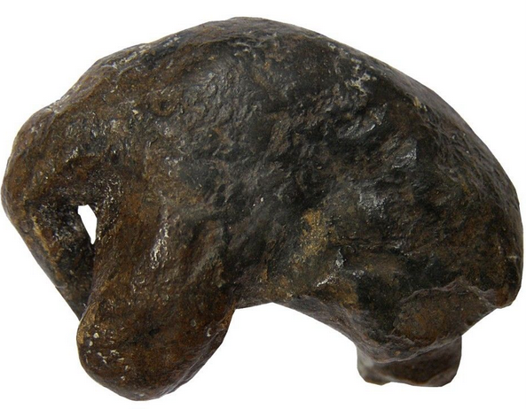

Fig. 1. Resin copy of the original carved of mammoth tusk

**Formal Label:** Czech Republic-Moravia-Dolní Věstonice-Figurine-Mammoth-26,000 BP**Display Description:** This ivory carving of a mammoth suggests that the artist was trying to capture the position of this animal in the midst of a howling snowstorm when all it could do was to protect its head from the pelting snow. This sculpture comes fromone of the most famous Moravian sites, Dolní Věstonice, situated on the hill of Pollau at 549 m asl (1,801 ft). Since remains of molluscs, spruce and pollen from the site suggest that it was occupied during a cold climate with a tundra environment this could well explain the pose of the mammoth sculpted here. This site was excavated in the 1920s and again in 1947-52 (Klima 1963), and it has been a source of artifacts of the Gravettian period (27,000-20,000 BP).

**Accession Number: A130**

**LC Classification:** GN772.22.C95

**Date or Time Horizon:** 26,000 BP C14.

**Geographical Area:** Czech Republic, Dolní Věstonice, Moravia, at the base of the hill of Pollau.

**Map, GPS Coodinates**: 48.88822 16.64369, 40° 26' 46" N 79° 58' 56" W

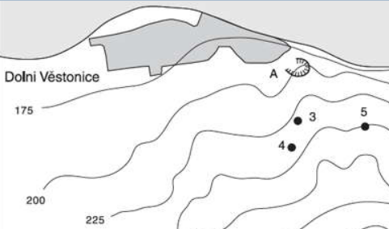 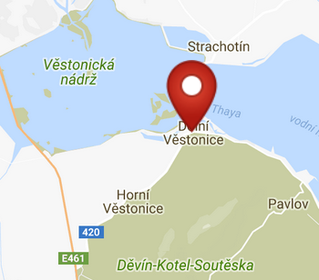 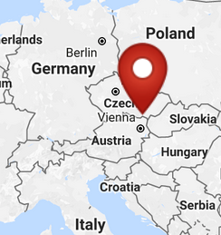

Fig. 2. Map of the location of Dolní Věstonice sites. Key: 3. Dolní Věstonice II; 4. Dolní Věstonice II-A; 5. Dolní Věstonice III; A. Dolní Věstonice source of stone. From Verpoorte 2000.

Figs. 3-4. Maps of the location of Dolní Věstonice from http://latitude.to/img/latitude-logo.svg.

**Cultural Affiliation:** Gravettian Period (27,000-20,000 BP)

**Medium:** mammoth ivory

**Dimensions:   
Weight: original, unknown.**

**Provenance: Moravian Museum in Brno, acc. No. 30020**

**Condition:** museum replica in resin.

**Discussion:** Dolní Věstonice, Moravia in the Czech Republic, is on the hill of Pollau 549 m (1,801 ft), dating to approximately 26,000 BP. The site has been a source of artifacts of the Gravettian period (27,000-20,000 BP).

**References:**

Klima, B. 1963. *Dolni Vestonice. Erforschung eine Lagenplatzes der Mammutjager an der Jahren 1947-52* Monum. Archaeol., XI.

Trinkaus, Erik and Jiri Svoboda (Eds.) 2005.*Early Modern Human Evolution in Central Europe: The People of Dolní Vestonice and Pavlov* (Human Evolution Series). New York: Oxford University Press.

Verpoorte, A**.** 2000. *Camps, boundaries and art*, https://openaccess.leidenuniv.nl/bitstream/handle/1887/13512/ASLU08_09.pdf